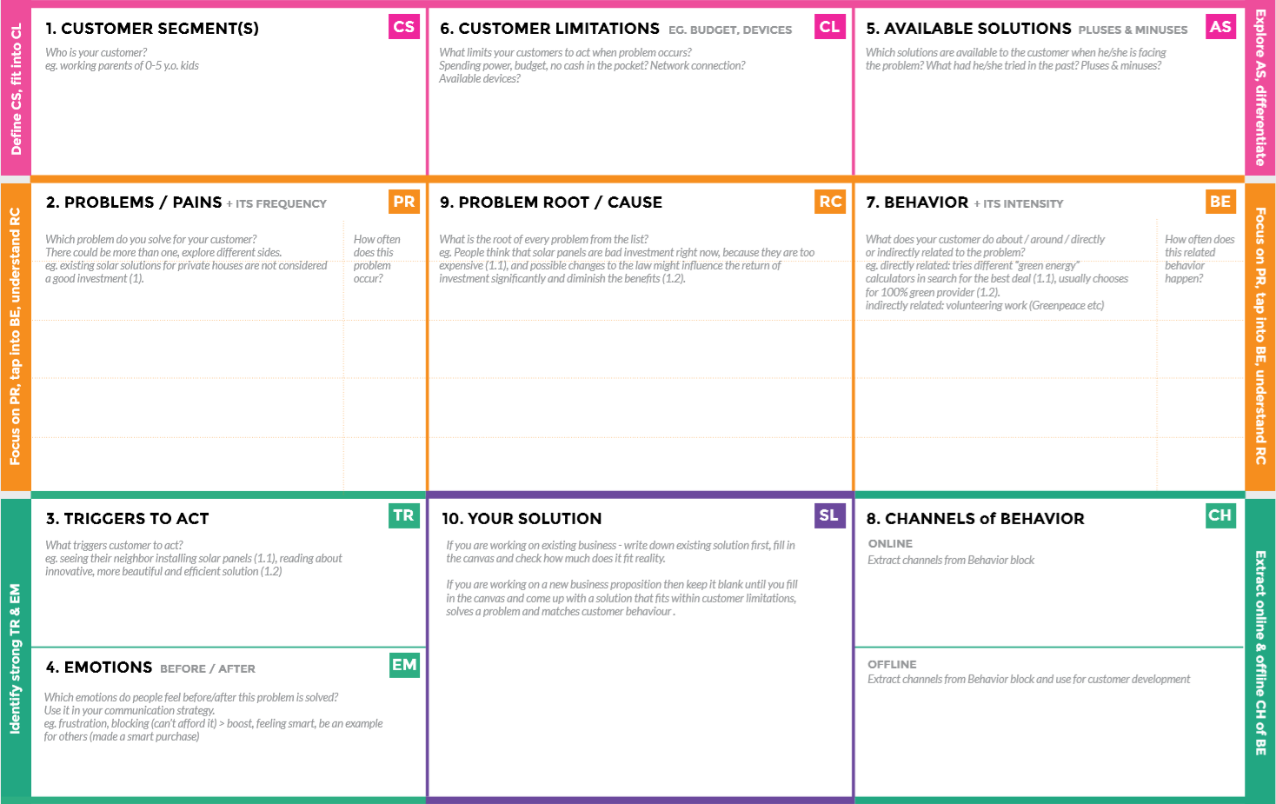
OFFLINE: The control action is taken by the farmers to monitor the farms.
ONLINE: The Data send through application for the farmers to know about the farms.
Direct related: Tries to find a solution to prevent this problem
Indirect related: Located in rural where internet connectivity might not be strong enough to facilitate fast transmission speeds.
Monitor different parameters and mobile or web application make easily to farm the crop field .
“IoT based Smart crop protection system for agriculture” !!
It help farmers grow more food on less land by protection crops from pests, diseases and weeds as well as raising productivity per hectare.

1)If temperature ,PH level ,humidity & light intensity makes the serious cause for the environment.
2)Farmer affected by less productivity which will affect in their profit.

1)High adoption costs , security concerns. 2)Not aware of the implementation of IoT in agriculture.
- It’s difficult to monitor and control
- Ain’t known if the application doesn’t work properly.
Farmer’s ! Who’s not near his field
Create opportunities to lift people out of poverty in developing nations. (Over 60% )
BEFORE: Finances, Heavy work overload and conflict in relationship.
AFTER: It will easier to make more yield in field

